

SYNBOT PROPOSAL
Your Business, Speaks Back to You.

Date: 04/01/2026
Classification: Confidential – Management Only

Property of NeuroLayer Limited.
Introduction - The SynBot
Your operation is built on data. Every transaction, every stock movement, every invoice, every employee record. The problem has never been the data, it has been the distance between that data, the information it contains and the decisions you need to make right now.
SynBot closes that distance. Powered by retrieval-augmented AI and connected directly to your business systems, it is your always on intelligence layer, one that understands your operations, answers your questions in plain language, and puts the right information in front of the right people at the right moment. No complex navigation. No reports to wait on. No technical expertise required. Just ask.
Executive Summary
Your manufacturing operations already run on a solid digital foundation powered by ERPNext, capturing critical data across inventory, procurement, and finance. However, as highlighted in the assessment, the core challenge is not the absence of data, but the delay in transforming that data into timely, actionable insight. Inventory risks such as stock imbalances, expiry exposure, and raw material shortages continue to surface as recurring issues because they are identified reactively rather than proactively.
NeuroLayer’s SynBot addresses this gap by introducing an intelligence layer that operates directly on top of your existing system, continuously analyzing live data and converting it into structured, decision ready outputs.
The Intelligence Layer
Your existing system already captures the data that drives your manufacturing process stock levels, procurement cycles, material movement, and financial records. Key risk indicators such as expiry exposure, stock imbalances, and raw material shortages are only visible after manual extraction and interpretation. This creates a lag between occurrence and response, allowing small inefficiencies to compound into recurring operational losses.

SynBot addresses this gap by introducing an intelligence layer that connects directly to your existing system, continuously interpreting live data and transforming it into actionable insight without disrupting your current workflows.
The system architecture diagram below effectively illustrates how this service could connect to ERPNext via API integration, showing the data flow from ERP modules into the intelligence layer, and then into dashboards, reports, and user interfaces.

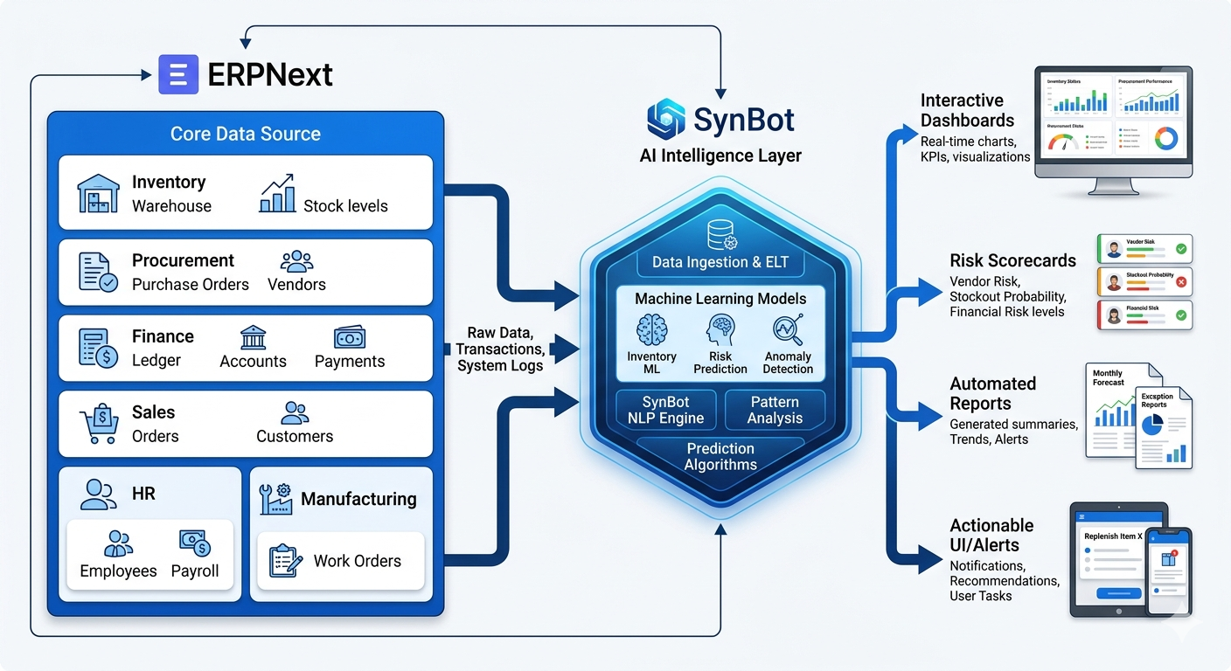
Fig.1 Integration Process.

Executive Operating System (EOS)
At the core of SynBot, is the Executive Operating System (EOS), where AI agents operate as embedded functional units across your operations. These agents are not passive observers, they actively evaluate patterns, detect anomalies, and initiate structured responses. When a deviation occurs such as a missed replenishment cycle or an approaching expiry threshold the system does not wait for manual reporting. It identifies the issue, classifies the level of risk, and initiates the appropriate workflow, including generating structured reports, assigning corrective actions, and escalating where necessary. This creates a controlled operational environment where risk is continuously monitored and addressed in real time, rather than reviewed retrospectively.

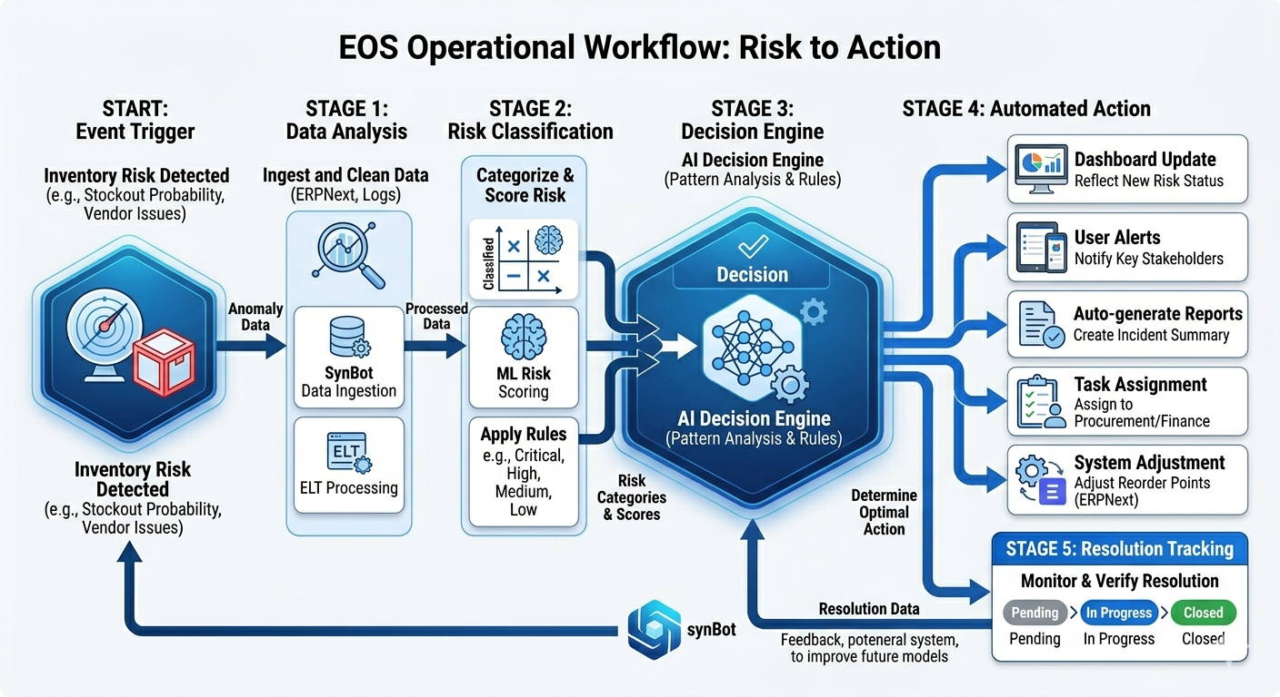
Figure. 2
The diagram above focuses on the EOS workflow, it demonstrates how an operational event, such as a stock risk trigger, moves through detection, classification, and automated response within the system.

Inventory Risk Control
The system’s adaptability ensures that it aligns precisely with your manufacturing processes rather than forcing process changes. SynBot is designed to integrate with existing workflows, whether in inventory management, quality assurance, or financial oversight, and can be configured to reflect your specific risk thresholds, reporting structures, and compliance requirements. This allows implementation to deliver immediate value while maintaining flexibility for future scaling. As your operations grow, the Bot evolves alongside them, continuously refining how risk is identified, measured, and managed.
The visual below, is centered on the Risk Scorecard, it would present how inventory risks are categorized and monitored in real time, providing a clear view of how decision-making is supported at both operational and executive levels.

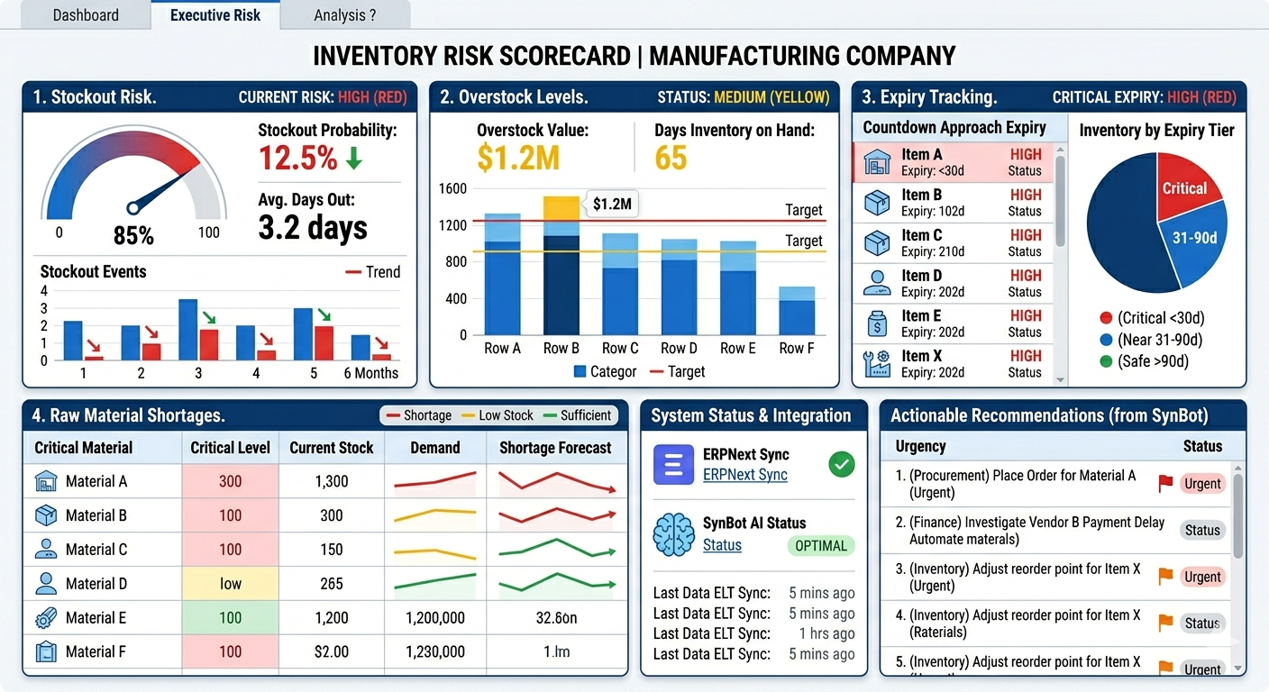
Figure 3.
These visual reinforce how SynBot transforms existing data into a structured, responsive system for managing inventory risk.

Executive Chat Interface.
This software also introduces a direct interaction layer that simplifies how your team engages with operational data. Instead of navigating complex ERP interfaces or relying on delayed reports, decision-makers can query the system in plain terms and receive immediate, context-aware responses drawn from live data. This capability extends across roles, enabling both operational staff and executive leadership to access the same intelligence without technical barriers. The result is faster decision cycles, improved coordination between departments, and a shift from reactive management to proactive control.
Customer Chat interface - Always On. Always Answering.
Before a prospect picks up the phone, before a client sends an email, SynBot is already there. Embedded directly on your website, the customer facing chat assistant handles the first conversation so your team doesn't have to. Visitors can ask about your services, get instant, accurate responses about what you offer, how you work, and how to get in touch at any hour, on any day.
It's not a generic bot with canned replies. It's trained on your company's actual knowledge base, so every answer reflects your brand, your services, and your voice. Leads captured through the chat are logged automatically and routed to your team, no follow-up slips through the cracks.
What it does:
- Answers company and service enquiries instantly
- Qualifies and captures visitor leads in real time
- Keeps prospects engaged while your team focuses on closing
Think of it as your most consistent, tireless front-desk representative one that never misses a message and always makes a strong first impression.

Conclusion
SynBot represents a strategic extension of your existing infrastructure rather than a replacement. It transforms the data into a system of intelligence, one that not only tracks what is happening across your operations but actively interprets and responds to it. This shift is critical for a manufacturing environment where timing, precision, and risk control directly impact profitability and operational stability.
By implementing this software, your organization moves from reactive management to proactive control, where risks are identified early, decisions are supported by real-time insight, and workflows are executed with consistency and accountability. The system’s ability to adapt to your processes ensures immediate value while positioning your operations for long-term scalability. Ultimately, it equips your business with the intelligence infrastructure required to operate with greater confidence, efficiency, and resilience in an increasingly data-driven manufacturing landscape.

